Task 7 due 09/28 at 9pm, 3-4 pages
- I would like each of you to give Victor Frankenstein an evaluation in terms of what he did well and not so well in his creation of the monster in Frankenstein. What are the positives of his experiment and his creation, and what are the negatives of the monster and the way Victor conducted his experiment?
- After looking at the slides of paintings in the "Realism" PowerPoint presentation, what are some connecting themes that you noticed in the paintings? Did you notice some similarities between them? And if these paintings are examples of Realism, then what might Realism mean as a genre and movement in art? What do you think might be particularly "real" about these paintings?
- After looking at the slides of paintings from question 2, and also after reading "Industrialism: Progress or Decline?" in the Norton Anthology and Charles Dickens's A Christmas Carol, how might industrialization in the 1800s be affecting the art world as well as the literary world? If the paintings in the slideshow as well as Dickens's novel are all examples of Realism, then discuss how industrialization connects to Realism, and what examples of industrialization and Realism can you see in A Christmas Carol?
- Charles Dickens's A Christmas Carol was written almost 180 years ago. Despite that, how consistent is Dickens’s story with your memories of the Christmas holiday? Whether your idea of Christmas is more religious or more secular, how is the world of Christmas that Dickens explores in A Christmas Carol consistent with your own Christmas experiences? What are some specific aspects and passages of the text that are either consistent with or inconsistent with our more modern Christmas?

Frankenstein book I already uploaded, it’s the download 4
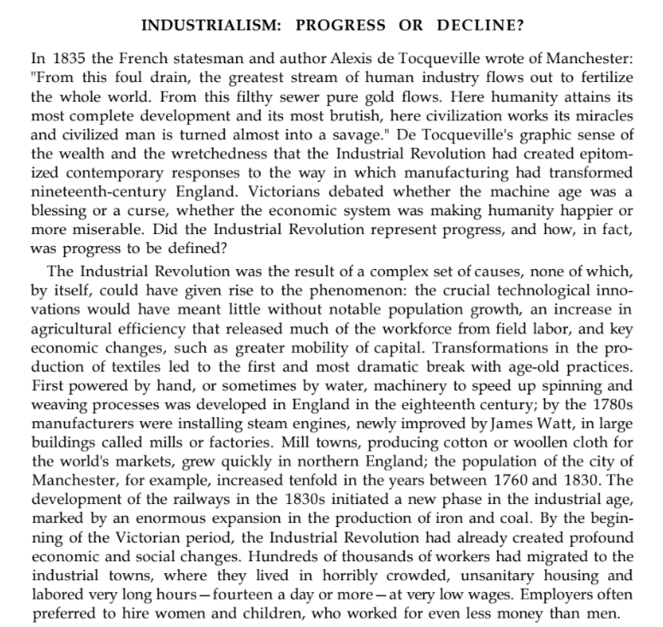
Christmas Carol, I will upload
Industrialism: Progress or Decline? Below:
